Module 4: Master Code Maintenance — "The Dictionary"

What is this module?
Master Code Maintenance manages short internal codes and what they mean —
essentially a lookup dictionary used across the whole application. Other
screens reference these codes as shorthand instead of repeating full text
everywhere.
It is a single maintenance surface with 15 total test definitions (13
regression, 2 smoke, 3 E2E-tagged).

Purpose — why this exists at all
Nearly every screen in this whole pricing suite (Price Codes, Buyer Groups,
Price Lists, Price Exceptions, Formulas...) uses a short internal `Type`
code — like `Category`, `Delete`, `reactivate`, `repurpose` — to classify
rows without repeating a full sentence every time. Master Code Maintenance
is the single dictionary that defines what each `(PageName, Type, Code)`
combination actually means, in plain English, via its `Description` and
`Explanation` fields. Without it, developers and support staff would have
no authoritative place to look up "what does Type `reactivate` on page
`Inactive price code maint` actually mean."

Where it is used
Each row is tagged with the exact screen (`PageName`) it belongs to — e.g.
`Buyer Group`, `Price code maint`, `Inactive price list maint`, `price
formula`, `Price Exceptions` — so this one grid documents codes used across
Modules 1 (Pricing), 2 (Buyer), and 8 (Price Exceptions) simultaneously.
The InUse column tells whoever is maintaining this dictionary whether a
given code is still actively referenced by its source screen before they
consider removing it.
Callout: 💡 **Example (real live Stage data):** Page `Buyer Group`, Type
Callout: `Category`, Code `BUYGRP` has Description `Buy Groups` and an editable
Callout: Explanation of `Buy Groups`. Compare that to page `Inactive price code
Callout: maint`, Type `reactivate`, Code `10`, Description `Deleted by mistake`,
Callout: Explanation `the price code was deleted by mistake` — the same-looking
Callout: `Type`/`Code` shape (`reactivate` / `10`) means something completely
Callout: different depending on which `PageName` it's scoped to, which is exactly
Callout: why `PageName` is part of the lookup key, not just `Code`.

Module flow at a glance
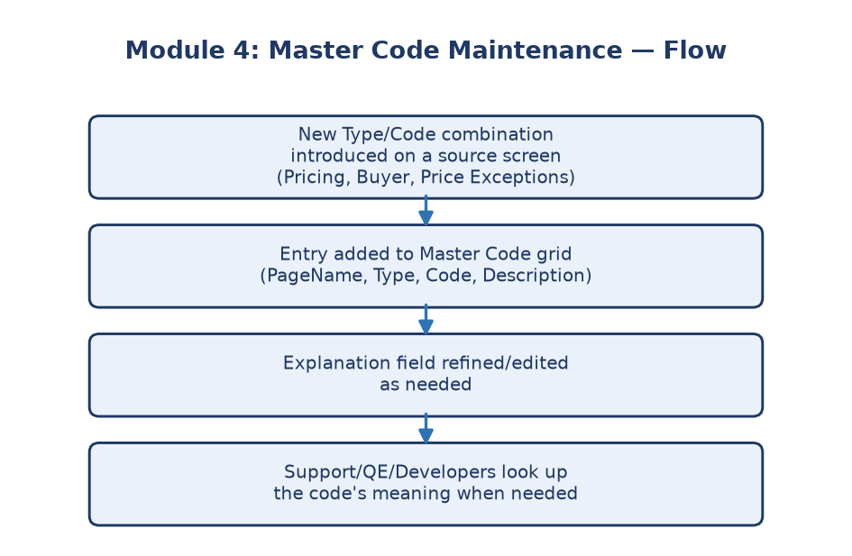
Module 4 flowchart
---

Submodule 4.1: Master Code Maintenance grid, filters, Add New, Save/Cancel, and Export (15 tests)
Screen location: Home → File Maintenance → Miscellaneous → Master Code
Maintenance
(`https://stage.ashleynet.com/PriceMaintenance_Net/MasterCode.aspx`)
What it is: One combined screen covering the full lifecycle of a
"Master Code" entry — its Page Name, Type, Code, Description, and
Explanation.
**Real fields observed on the live grid (Stage, Environment `ASHLEY
FURNITURE INDUSTRIES, LLC`):**
- Environment — dropdown scoping which company's codes are shown, same
pattern as Modules 1–3.
- Page name / Type — two free-text filter boxes plus a Search
button, letting you narrow the grid to one source screen and/or Type.
- Delete — checkbox per row; disabled on most rows (protected
system codes) but enabled on at least one observed row (Page `Price
Exceptions`, Type `Delete`, Code `10`), showing deletion eligibility
varies row by row.
- Initial — the page identifier shorthand (e.g. `P9`, `P1`, `P10`,
`P11`).
- PageName — the human-readable source screen (e.g. `Buyer Group`,
`Price code maint`, `Inactive price list maint`, `price formula`, `price
list and comm adj`).
- Type — the classification within that page (e.g. `Category`,
`Delete`, `reactivate`, `repurpose`, `delete`).
- Code — disabled textbox holding the actual short code (e.g.
`BUYDWN`, `CUSSP`, `DNU`, `Land`, `10`, `900`).
- Description — disabled textbox with a short label (e.g. `Buy Downs`,
`Do not use`, `Deleted by mistake`).
- Explanation — the one field that is editable in every row (e.g.
`Buy Downs`, `the price code was deleted by mistake`, `Item was
repurposed by user`).
- InUse — `Y` on nearly every observed row, and blank on the one row
with an enabled Delete checkbox (Page `Price Exceptions`, Code `10`) —
suggesting `InUse = blank/N` is what actually unlocks the Delete
checkbox.
- Toolbar: Add New, Save, Cancel, Export To Excel.
Callout: ℹ️ **Note:** Only the **Explanation** column is directly editable on this
Callout: grid — `Code` and `Description` are shown as disabled textboxes (visible
Callout: but not typed into), so this screen is really meant for refining the
Callout: long-form explanation of an existing code, not renaming the code itself.
What's explicitly NOT covered: Master Code does not have confirmed
linked inactive, defaults, members/customer, pricing, Update Queue,
upload, or separate popup routes — these are intentionally excluded rather
than guessed at or invented.
Purpose: Every code (like a page identifier or a category type) used
elsewhere in AshleyNET needs a definition somewhere — this is that
definition source. If this dictionary is wrong or has duplicate/unclear
entries, everything referencing those codes downstream becomes confusing or
inconsistent.
---

Why this module matters
It's small but foundational — many other modules (Pricing, Buyer, Code
Cross Reference, Price Exceptions) rely on consistent codes. Keeping this
dictionary clean and correct prevents subtle bugs elsewhere in the system.
Business impact if this module breaks: A wrong or missing Explanation
means support staff and QE can't confidently tell what a given
`Type`/`Code` combination on another screen (e.g. why an item shows Type
`repurpose`) actually means — turning a two-second lookup into a
guessing game or an escalation.
Who relies on this module: Application support/QE (look up what an
unfamiliar Type/Code combination means), Developers (reference this as the
canonical code dictionary when building new features on top of existing
codes), and indirectly every module that displays a `Type`/`Code` pair
sourced from here (Buyer, Pricing, Price Exceptions).

